

EA Assignment Project

ITE3006: it essential-web

THAJUDEEN Kamel Mohamed | 170048116 | ITA114112/1A

# Why I decided to make this website?

the reason for me to create this website is, mini restaurant webpage it’s pretty easy to make and visitors can easily understand what's this webpage is actually about by just looking at the design. Not only that creating a restaurant it’s one of my dream too, so I thought this would be a great opportunity to improve my knowledge in making a webpage related to restaurant. Moreover, this webpage can be relatable to other restaurant webpage by that I mean this webpage can be also used for daily life if I make more serious upgrade. by making this webpage I’ve really improved my skills in CSS and HTML. So, that’s the reason why I decided to make this website.

**There are several pages that I made:**

* Home
* About
* Pricing
* More
* Contact us

## about each PAGE

**Home page** it’s just a normal welcoming page which gives visitors information on why this website was created.

On the **About page** visitors can see what is the website is really about and what’s the purpose of using this webpage.

Since this website’s main idea is about a mini restaurant, visitors can click the **Pricing page** in order to know the food price and they can see the menu of the restaurant.

you can see the variety of drinks and dessert offered by this restaurant by going to **More page.**

Lastly, the **Contact us page** was created for the visitors to contact the restaurant and they can even leave feedback on this page.

## How this website was created?

This webpage was simply made by using **Notepad Tool and used basic html coding.** For the designing, I used **CSS coding** on a Separate notepad and link them with each page I’ve created. Not only that for some part I’ve used **Dreamweaver** to do it. I have to use Dreamweaver for some part because I have to arrange pictures in left side and text in the right side that’s the reason why I have used Dreamweaver but not for every part.

# How does the webpage look like?

**These are some screenshots of my webpage:**

This is an **Responsive webpage** which means this website can be viewed in two ways which is PC displaying and mobile displaying.

**This is the Normal PC viewing (768px) of the webpage:**

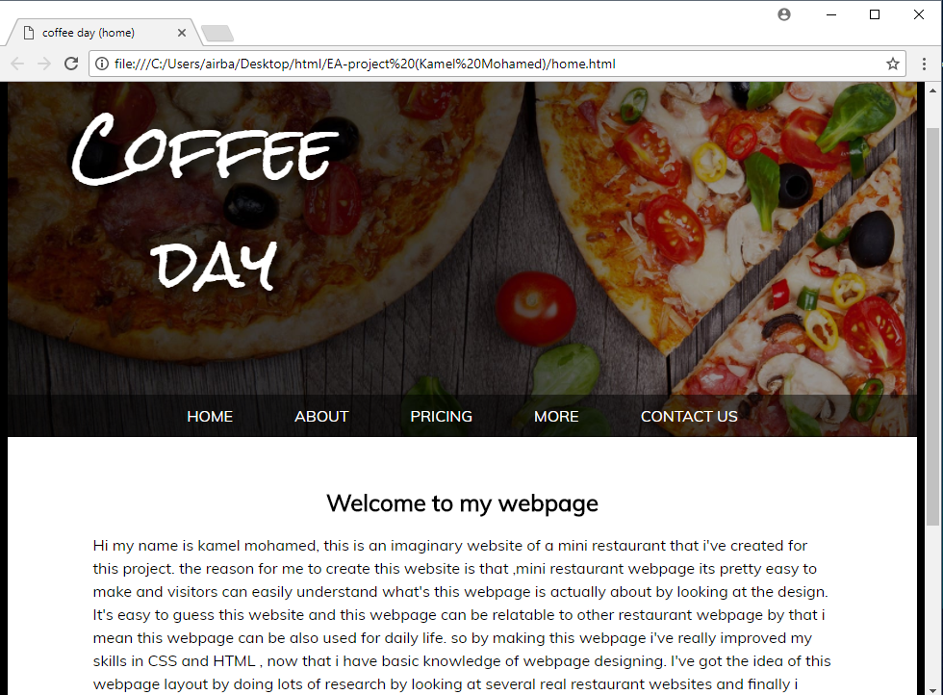

**This is the normal mobile viewing (430px) of the webpage:**

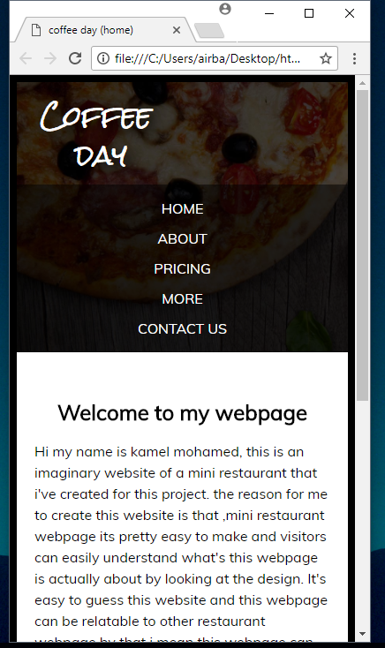

Lastly, pictures size will change if the users tries to drag the webpage around. Like for example, if they maximize the page the pictures and heading in the webpage will looks a bit bigger. If they drag it to a smaller size the pictures will get smaller accordingly.

## Demo of each page

In order to make this webpage I have made 2 separate CSS file one is called **CSS** and other is called **CSS2** the reason for me to create CSS2 is because I wanted to design and link the **CONTACT US** page to add validation code. Every pages is linked to CSS except the CSS2 file because CSS2 file is only created for **Contact us** page.

**This is how the about page looks like:**

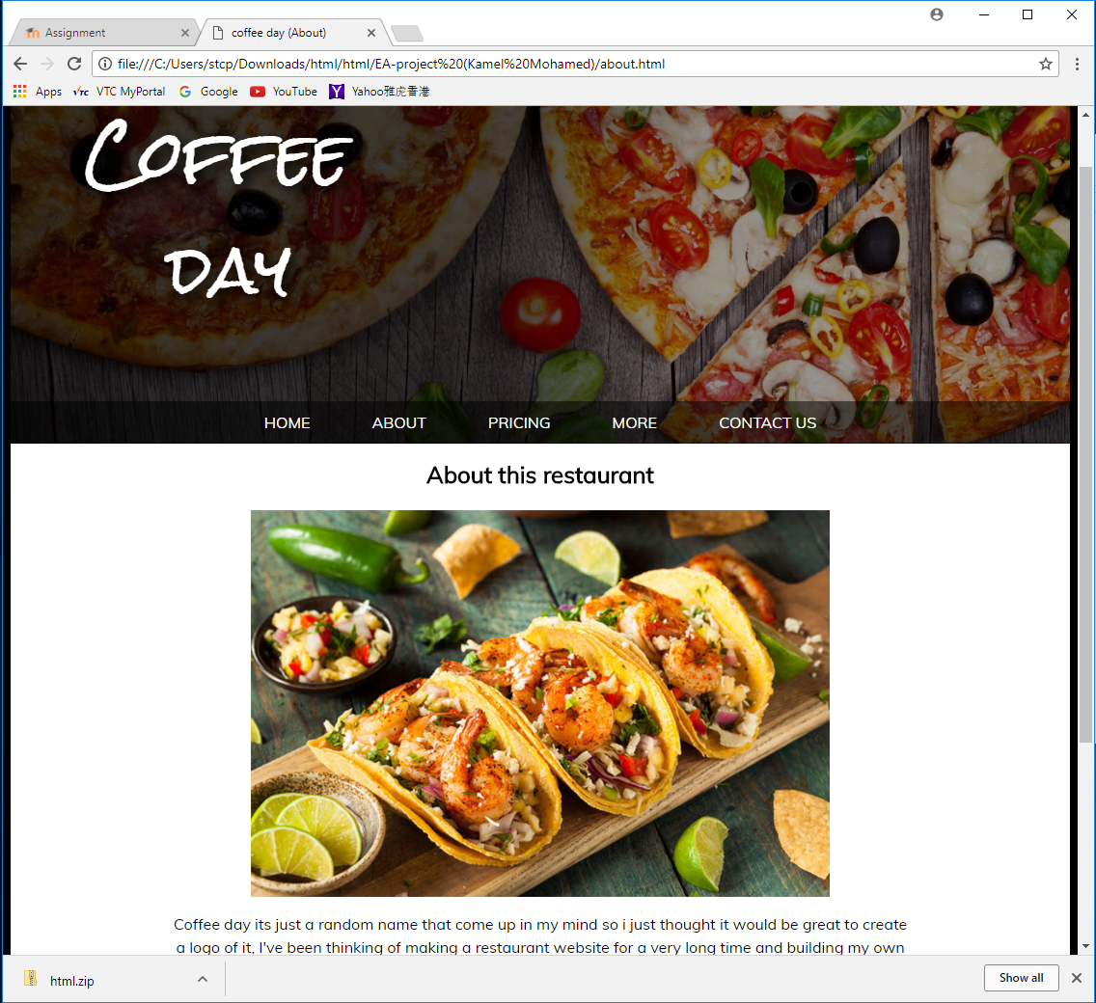

**This is how the Home page looks like:**

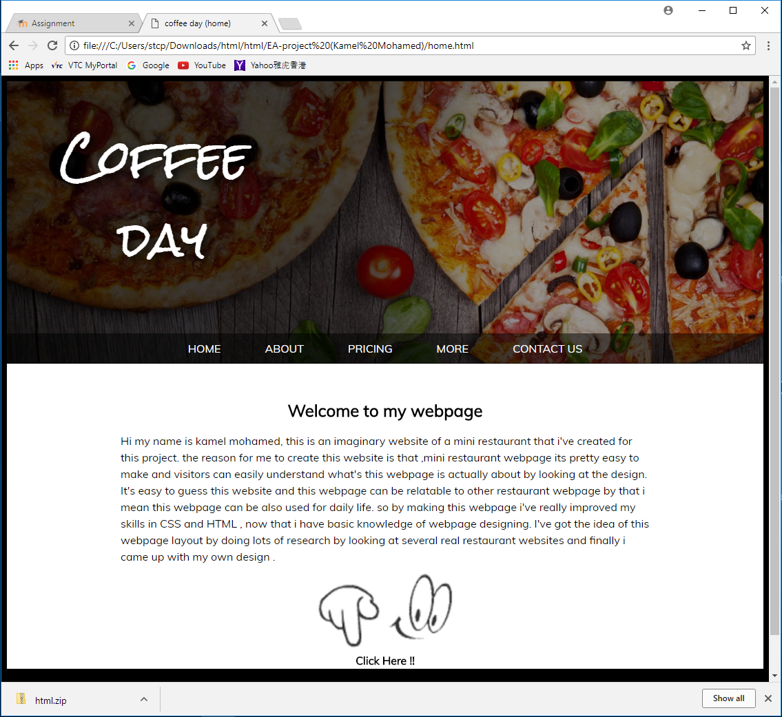

As you notice from the picture bottom side there’s a gif and click here text. That click here text is actually linked to the other outside world website.

**This is how the Pricing page looks like:**

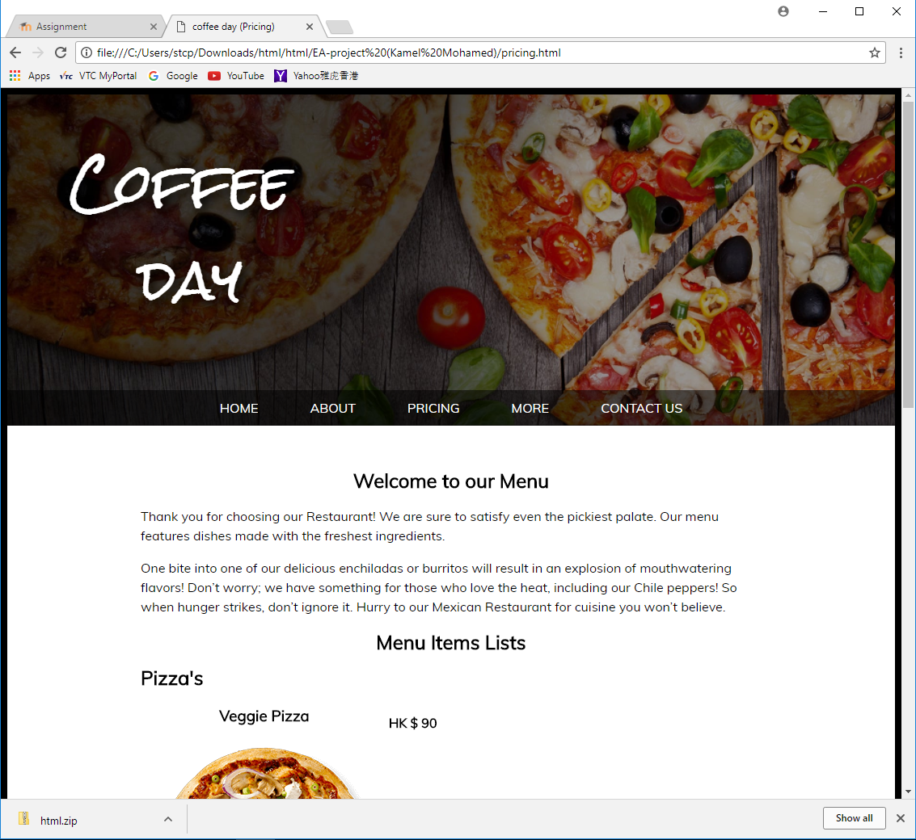

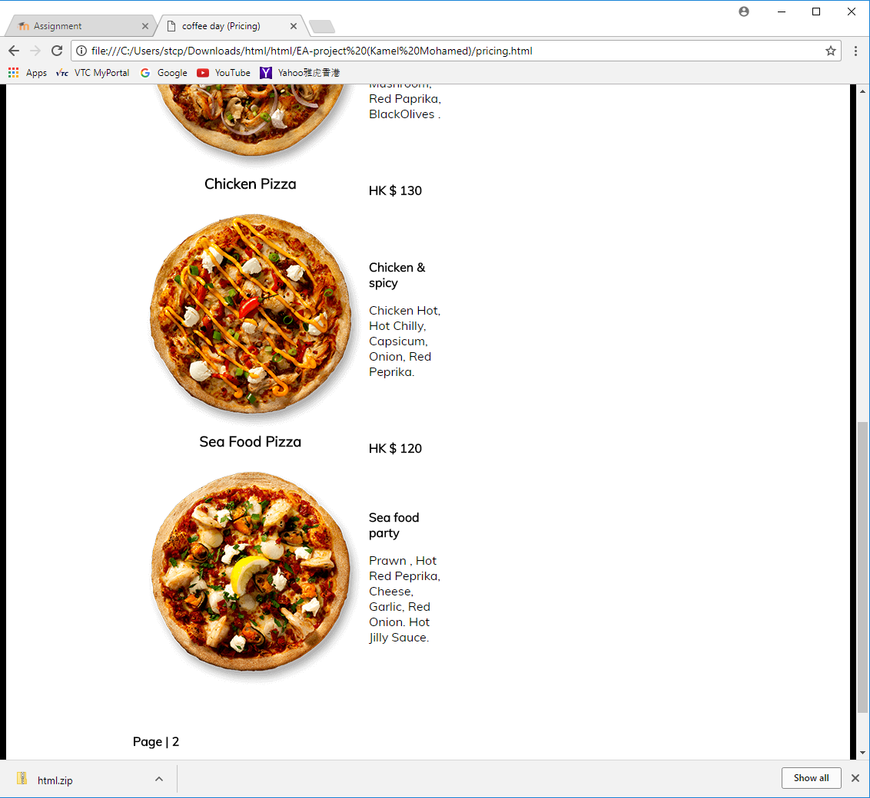

In this page as you can see in the bottom left side there’s a page 2 text which linked to an another page. The reason for adding more pages it’s because I want to add more variety of food items. For arranging the pics in left and text in right side I used tables to do that by using Dreamweaver software.

**This is how the more page looks like:**

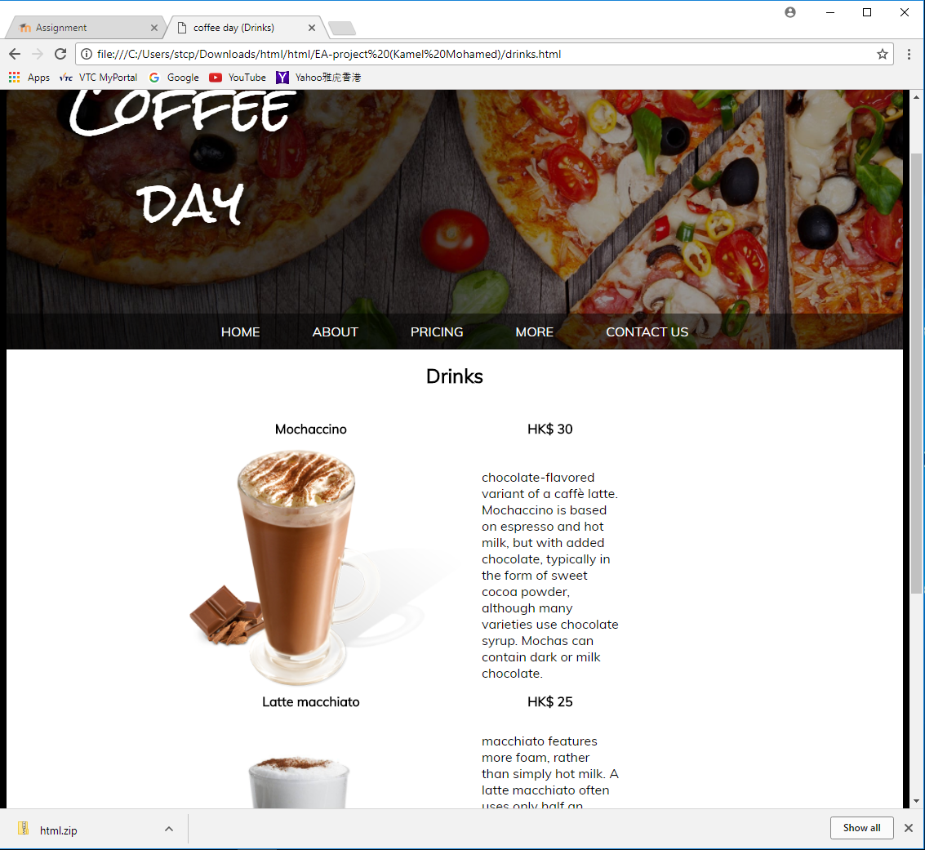

For this page there’s some special thing that I’ve added. When you hover over the more page there will be a scroll down which will bring you to another page. In the scroll down you can see two pages called Drinks and Desserts.

**This is how the Contact us page looks like:**

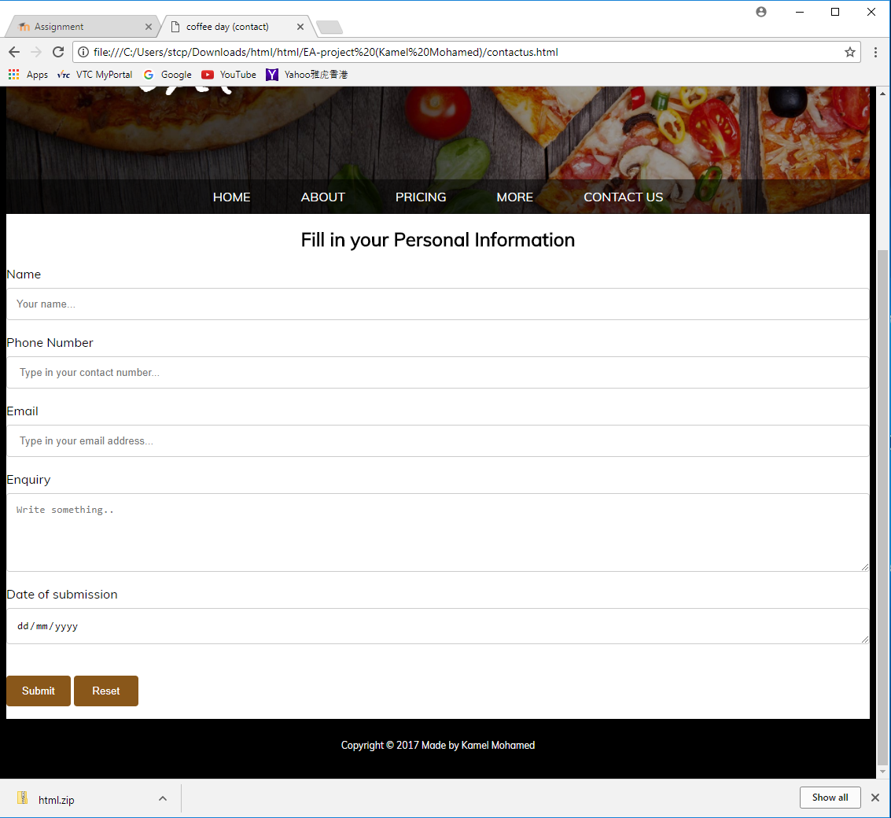

In this page I have added some validation codes like for example if you leave the name textbox blank and click the submit button you will get an alert popup saying its empty. For this page design I linked it to both CSS and CSS2 file.

**THE END**